# BUILDING CHECKOUT CONTAINER:

Folder structure: Create CheckoutSummary.js and css inside CheckoutSummary folder inside of Order. Create Checkout.js inside Checkout folder of container.

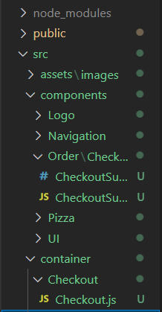

CheckoutSummary.js:

import React from 'react';

import Pizza from '../../Pizza/Pizza';

import Button from '../../UI/Button/Button';

import './CheckoutSummary.css';

const checkoutSummary = (props) => {

    return(

        <div className='CheckoutSummary'>

            <h1>We hope it is good!</h1>

            <div style={{width:'100%',margin:'auto'}}>

                <Pizza ingredients={props.ingredients}/>

            </div>

            <Button

            btnType="Danger"

            clicked>CANCEL</Button>

            <Button

            btnType="Success"

            clicked>CONTINUE</Button>

        </div>

    );

}

export default checkoutSummary;

CheckoutSummary.css

.CheckoutSummary{

    text-align: center;

    width: 80%;

    margin: auto;

}

@media (min-width: 600px){

    .CheckoutSummary{

        text-align: center;

        width: 500px;

        margin: auto;

    }

}

Checkout.js

import React,{useState} from 'react';

import CheckoutSummary from '../../components/Order/CheckoutSummary/CheckoutSummary';

const Checkout = () => {

    const [state,setState] = useState({

        ingredients: {

            salad:1,

            meat: 1,

            cheese: 1,

            bacon: 1,

        }

    });

    return(

        <div>

        <CheckoutSummary ingredients={state.ingredients}/>

        </div>

    );

}

export default Checkout;

App.js

import React from 'react';

import Layout from '../hoc/Layout/Layout';

import PizzaBuilder  from './PizzaBuilder/PizzaBuilder';

import Checkout from './Checkout/Checkout';

const App = () => {

  return(

    <div className="App">

      <Layout>

        <PizzaBuilder/>

        <Checkout/>

      </Layout>

    </div>

  )

}

export default App;

OUTPUT:

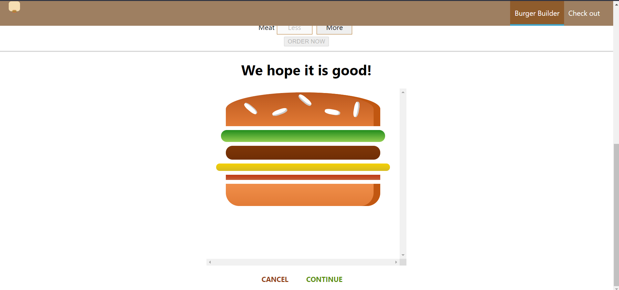

# SETTINGS UP ROUTERS AND ROUTES:

Installation: npm install –save react-router-dom

NOTE: You can also add BroswerRouter in app.js but here we add in index.js

Index.js

import React from 'react';

import ReactDOM from 'react-dom';

import './index.css';

import App from './container/App';

import reportWebVitals from './reportWebVitals';

import {BrowserRouter} from 'react-router-dom'

const app = (

  <BrowserRouter>

    <App/>

  </BrowserRouter>

);

ReactDOM.render(app,document.getElementById('root')

);

reportWebVitals();

App.js

import React from 'react';

import Layout from '../hoc/Layout/Layout';

import PizzaBuilder  from './PizzaBuilder/PizzaBuilder';

import Checkout from './Checkout/Checkout';

import { Route } from 'react-router-dom';

const App = () => {

  return(

    <div className="App">

      <Layout>

        <Route path="/" component={PizzaBuilder} />

        <Route path="/checkout" component={Checkout} />

      </Layout>

    </div>

  )

}

export default App;

NOTE: You can also add Switch

App.js

import React from 'react';

import Layout from '../hoc/Layout/Layout';

import PizzaBuilder  from './PizzaBuilder/PizzaBuilder';

import Checkout from './Checkout/Checkout';

import { Route,Switch } from 'react-router-dom';

const App = () => {

  return(

    <div className="App">

      <Layout>

        <Switch>

          <Route path="/checkout" component={Checkout} />

          <Route path="/" exact component={PizzaBuilder} />

        </Switch>

      </Layout>

    </div>

  )

}

export default App;

# NAVIGATING TO CHECKOUT PAGE:

ADVANCE LEVEL:

import React from 'react';

import './Pizza.css';

import PizzaIngredients from './PizzaIngredients/PizzaIngredients';

import { withRouter } from 'react-router-dom';

const Pizza = (props) => {

    console.log(props)

    let transfromedingredients = Object.keys(props.ingredients)

    .map(igKey => {

        return [...Array(props.ingredients[igKey])].map((_, i) => {

            return <PizzaIngredients key={igKey + i} type={igKey} />

        }) //[] of two elemenst

    })

    .reduce((arr, el) => { // convert aboves arrays into one array

        return arr.concat(el)

    },[]);

    // console.log(transfromedingredients);

    if(transfromedingredients.length === 0){

        transfromedingredients = <h4>Please add some ingredients</h4>

    }

    return(

        <div className='Pizza'>

        <PizzaIngredients type="bread-top" />

        {transfromedingredients}

        <PizzaIngredients type="bread-bottom" />

        </div>

    );

}

export default withRouter(Pizza);

OUTPUT:  
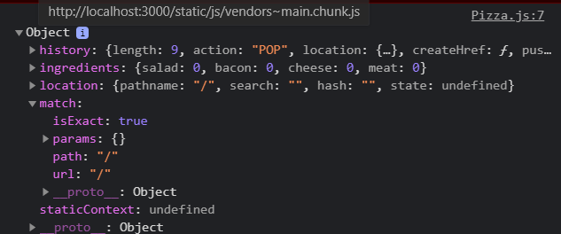

OUR MAIN WAY:

PizzaBuilder.js

const PizzaBuilder = (props) => {

    const [state, setstate] = useState({

        ingredients: {

            salad: 0,

            bacon: 0,

            cheese: 0,

            meat: 0

        },

        totalPrice: 4,

    });

const purcharseContinueHandler = () => {

        // alert('continue')

        console.log(props);

        props.history.push('/checkout');

    }

OUTPUT:

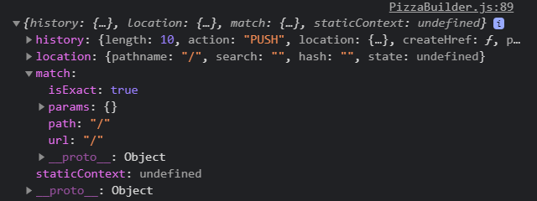

AFTER CLICKING CONTINUE BUTTON OF YOUR ORDER… IT WILL REDIRECT USER TO CHECKOUT PAGE.

# NAVIGATING BACK AND TO NEXT PAGE:

NOTE: When user click cancel, it will redirect to home page and clicking on continue to change the url to ‘/checkout/contact-data’. We are doing this by using props history : goBack() and replace().

CheckoutSummary.js

<Button

                btnType="Danger"

                clicked={props.checkoutCancelled}

                >CANCEL</Button>

            <Button

                btnType="Success"

                clicked={props.checkoutContinued}

                >CONTINUE</Button>

Checkout.js

checkoutCancelledHanlder = () => {

        props.history.goBack();

    }

    checkoutContinuedHandler = () => {

        props.history.replace('/checkout/contact-data');

    }

    return(

        <div>

        <CheckoutSummary

            ingredients={state.ingredients}

            checkoutCancelled={checkoutCancelledHanlder}

            checkoutContinued={checkoutContinuedHandler}

        />

        </div>

    );

# PASSING INGRDEINTS VIA QUERY PARAMS:

NOTE: PASSING REAL INGREDIENTS TO CHECKOUT PAGE FROM HOME PAGE( WHERE WE SELECT INGREDIENTS).

pathname: '/checkout',

            search: '',

THESE ARE JAVASCRIPT OBJECT CODE.

PizzaBuilder.js

const purcharseContinueHandler = () => {

        // console.log(props);

        const queryParams= []; //empty array

        for( let i in state.ingredients){

            queryParams.push(encodeURIComponent(i) + '=' + encodeURIComponent(state.ingredients[i]));

        }

        const queryString = queryParams.join('&');

        props.history.push({

            pathname: '/checkout',

            search: '?'+queryString,

        });

    }

OUPUT AFTER CLICKING CONTINUE:  
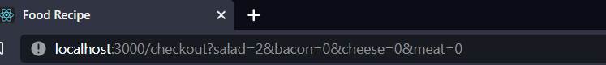

TO SHOW IN CHECKOUT BURGER CSS:  
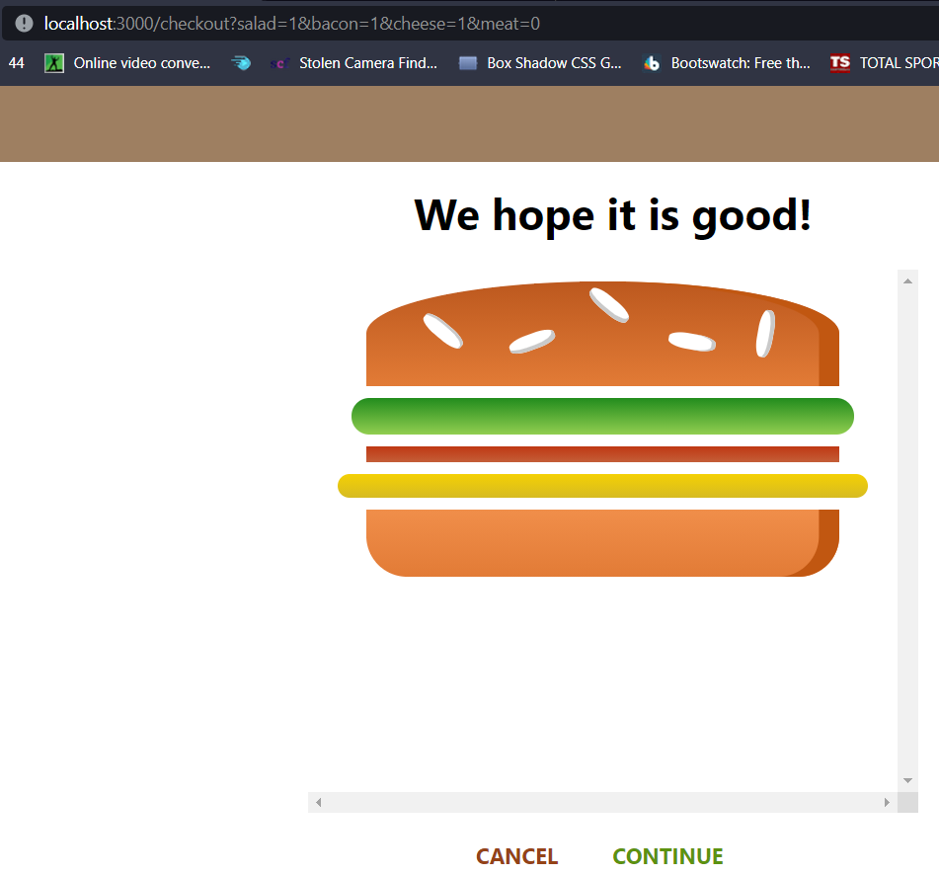

Checkout.js

useEffect() = Similar to componentDidMount and componentDidUpdate.

URLSearchParams: The **URLSearchParams** interface defines utility methods to work with the query string of a URL. An object implementing **URLSearchParams** can directly be used in a for...of structure, for example the following two lines are equivalent: for (const [key, value] of mySearchParams) {} for (const [key, value] of mySearchParams

import React,{useState,useEffect} from 'react';

import CheckoutSummary from '../../components/Order/CheckoutSummary/CheckoutSummary';

const Checkout = (props) => {

    const [state,setState] = useState({

        ingredients: {

            salad:1,

            meat: 1,

            cheese: 1,

            bacon: 1,

        }

    });

    useEffect(() => {

        const query= new URLSearchParams(props.location.search);

        const ingredients = {};

        for(let param of query.entries()){

            //['salad','1']

            ingredients[param[0]] = +param[1];

        }

        // console.log('ING:',ingredients)

        setState({ingredients: ingredients})

    }

    );

# NAVIGATING TO CONTACT DATA COMPONENT:

NOTE: Create ContactData.js in Contact(which should be created inside CheckOut folder. We are going to route ContactData page from Checkout page.

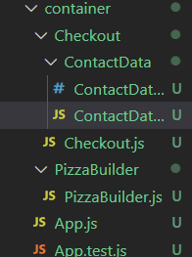

ContactData.js

import React, { useState } from 'react';

import Button from '../../../components/UI/Button/Button';

import './ContactData.css'

const ContactData = () => {

    const [state,setState] = useState({

        name: '',

        email: '',

        address: {

            street: '',

            postalCode:''

        }

    });

    return(

        <div className="ContactData">

            <h4>ENTER CONTACT</h4>

            <form>

                <input className="Input"

type='text' name="name" placeholder="Your Name" />

                <input className="Input" type='email'

name="email" placeholder="Your Email" />

                <input className="Input" type='text'

name="street" placeholder="Your Street" />

                <input className="Input" type='text'

name="postal" placeholder="Your Postal COde" />

                <Button btnType="Success">ORDER</Button>

            </form>

        </div>

    );

}

export default ContactData;

ContactData.css

.ContactData {

    margin:  20px auto;

    width: 80%;

    text-align: center;

    box-shadow: 0 2px 3px #ccc;

    border: 1px solid #eee;

    padding: 10px;

    box-sizing: border-box;

}

.Input {

    display: block;

}

@media (min-width: 600px){

    .ContactData {

        width: 500px;

    }

}

Checkout.js

import {Route} from 'react-router-dom';

import ContactData from './ContactData/ContactData';

return(

        <div>

        <CheckoutSummary

            ingredients={state.ingredients}

            checkoutCancelled={checkoutCancelledHanlder}

            checkoutContinued={checkoutContinuedHandler}

        />

        <Route path={props.match.path+ '/contact-data'} component={ContactData}/>

        </div>

    );

# ERROR:

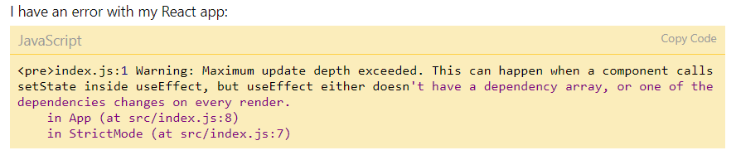

Yes! I solved this problem! It was because of the useEffect(), but it wasn't because it was being used twice.  
  
The problem was because I didn't add an empty array to my useEffect() function so that it would have only run once:

JavaScript

Copy Code

*// Save to Load*

const saveLocalTodos = () => {

localStorage.setItem("todos", JSON.stringify(todos));

};

const getLocalTodo = () => {

if (localStorage.getItem("todos") === null) {

localStorage.setItem("todos", JSON.stringify([]));

} else {

let todoLocal = JSON.parse(localStorage.getItem("todos"));

setTodos(todoLocal);

}

};

useEffect(() => {

getLocalTodo();

}, []);

# KEY ERROR IN MAP:



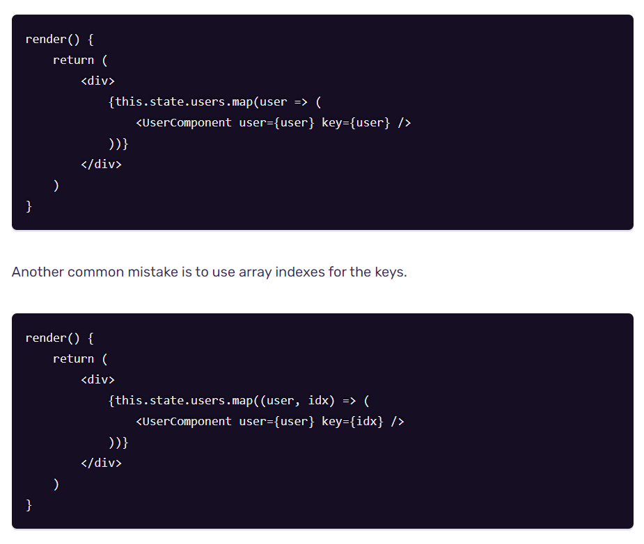

# ORDER SUBMISSION AND PASSING DATA BETWEEN PAGES:

ContactData.js

import React, { useState } from 'react';

import Button from '../../../components/UI/Button/Button';

import './ContactData.css'

const ContactData = (props) => {

    const [state,setState] = useState({

        name: '',

        email: '',

        address: {

            street: '',

            postalCode:''

        }

    });

    const orderHandler = (event) => {

        event.preventDefault();

        console.log(props.ingredients)

    }

    return(

        <div className="ContactData">

            <h4>ENTER CONTACT</h4>

            <form>

                <input

                 className="Input"

                 type='text'

                 name="name"

                 placeholder="Your Name" />

                <input

                 className="Input"

                 type='email'

                 name="email"

                 placeholder="Your Email" />

                <input

                 className="Input"

                 type='text'

                 name="street"

                 placeholder="Your Street" />

                <input

                className="Input"

                type='text'

                name="postal"

                placeholder="Your Postal COde" />

                <Button

                btnType="Success"

                clicked={orderHandler}>ORDER</Button>

            </form>

        </div>

    );

}

export default ContactData;

# ADDING AN ORDERS PAGE:

Create Orders Folder inside container and orders.js inside it.

Orders.js:

import React from 'react';

import Order from '../../components/Order/Order';

const Orders = () => {

    return(

        <div>

            <Order />

            <Order />

        </div>

    );

}

export default Orders;

Create Order.js and Order.css inside of Order Folder of Order.

Order.js

import React from 'react';

import './Order.css';

const Order = (props) => {

    return(

        <div className='Order'>

            <p>ingredients: Salad (1)</p>

            <p>ingredients: <strong>USD 122.</strong></p>

        </div>

    );

}

export default Order;

Order.css

.Order {

    width: 100%;

    border:  1px solid #eee;

    box-shadow:  0 2px 3px #ccc;

    padding: 10px;

    margin: 10px auto;

    box-sizing:border-box;

}

App.js

import React from 'react';

import Layout from '../hoc/Layout/Layout';

import PizzaBuilder  from './PizzaBuilder/PizzaBuilder';

import Checkout from './Checkout/Checkout';

import Orders from './Orders/Orders';

import { Route,Switch } from 'react-router-dom';

const App = () => {

  return(

    <div className="App">

      <Layout>

        <Switch>

          <Route path="/checkout" component={Checkout} />

          <Route path="/orders" component={Orders} />

          <Route path="/" exact component={PizzaBuilder} />

        </Switch>

      </Layout>

    </div>

  )

}

export default App;

# IMPLEMENTING NAVIGATION LINKS:

NavigationsItems.js

import React from 'react';

import './NavigationItems.css';

import NavigationItem from './NavigationItem/NavigationItem';

const NavigationItems = () => (

    <ul className='NavigationItems'>

        <NavigationItem link="/" extact>

        {/* //active is boolean so it can be passed like this */}

            Burger Builder

        </NavigationItem>

        <NavigationItem link="/orders">

            Orders

        </NavigationItem>

    </ul>

);

export default NavigationItems;

NavigationItem.js

import React from 'react';

import './NavigationItem.css';

import { NavLink } from 'react-router-dom'

const NavigationItem = (props) => (

    <li className='NavigationItem'>

    <NavLink

        to={props.link}

        activeClassName='active'

        exact={props.exact}

    >

    {props.children}

    </NavLink>

    </li>

);

export default NavigationItem;

# FETCHING ORDERS:

Fetching orders from firebase with axios and useeffect.

# OUTPUTTING THE ORDERS:

Orders.js

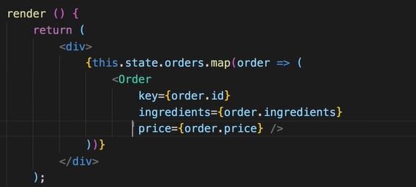

Order.js

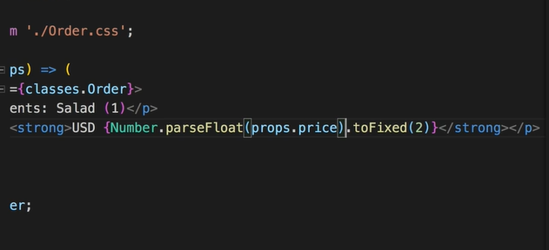

For ingredients:

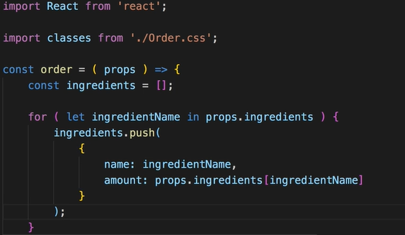

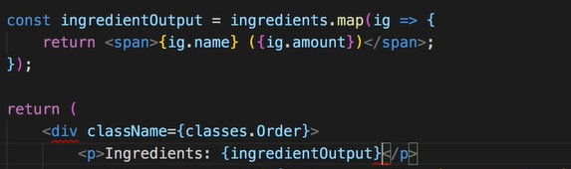

Style:

